### Semester One Examination, 2017

### Question/Answer booklet

# MATHEMATICS

**SOLUTIONS**

**METHODS**

**UNIT 1**

## Section Two:

## Calculator-assumed

|  |  |  |  |  |  |  |  |  |  |  |
| --- | --- | --- | --- | --- | --- | --- | --- | --- | --- | --- |
| Student Number: In figures |  |  |  |  |  |  |  |  |  |  |

In words

Your name

## Time allowed for this section

Reading time before commencing work: ten minutes

Working time: one hundred minutes

## Materials required/recommended for this section

***To be provided by the supervisor***

This Question/Answer booklet

Formula sheet (retained from Section One)

***To be provided by the candidate***

Standard items: pens (blue/black preferred), pencils (including coloured), sharpener, correction fluid/tape, eraser, ruler, highlighters

Special items: drawing instruments, templates, notes on two unfolded sheets of A4 paper, and up to three calculators approved for use in this examination

## Important note to candidates

No other items may be taken into the examination room. It is **your** responsibility to ensure that you do not have any unauthorised material. If you have any unauthorised material with you, hand it to the supervisor **before** reading any further.

## Structure of this paper

|  |  |  |  |  |  |
| --- | --- | --- | --- | --- | --- |
| Section | Number of questions available | Number of questions to be answered | Working  time (minutes) | Marks available | Percentage of examination |
| Section One:  Calculator-free | 7 | 7 | 50 | 52 | 35 |
| Section Two:  Calculator-assumed | 11 | 11 | 100 | 85 | 65 |
|  | | |  | **Total** | 100 |

## Instructions to candidates

1. The rules for the conduct of examinations are detailed in the school handbook. Sitting this examination implies that you agree to abide by these rules.

2. Write your answers in this Question/Answer booklet.

3. You must be careful to confine your response to the specific question asked and to follow any instructions that are specified to a particular question.

4. Additional working space pages at the end of this Question/Answer booklet are for planning or continuing an answer. If you use these pages, indicate at the original answer, the page number it is planned/continued on and write the question number being planned/continued on the additional working space page.

5. Show all your working clearly. Your working should be in sufficient detail to allow your answers to be checked readily and for marks to be awarded for reasoning. Incorrect answers given without supporting reasoning cannot be allocated any marks. For any question or part question worth more than two marks, valid working or justification is required to receive full marks. If you repeat any question, ensure that you cancel the answer you do not wish to have marked.

6. It is recommended that you do not use pencil, except in diagrams.

7. The Formula sheet is not to be handed in with your Question/Answer booklet.

Section Two: Calculator-assumed 65% (85 Marks)

This section has**eleven (****11)** questions. Answer **all** questions. Write your answers in the spaces provided.

Working time: 100 minutes.

Question 8 (6 marks)

(a) The variables and are directly proportional to each other, so that when , it is known that . Sketch a graph of the relationship between and on the axes below. (3 marks)

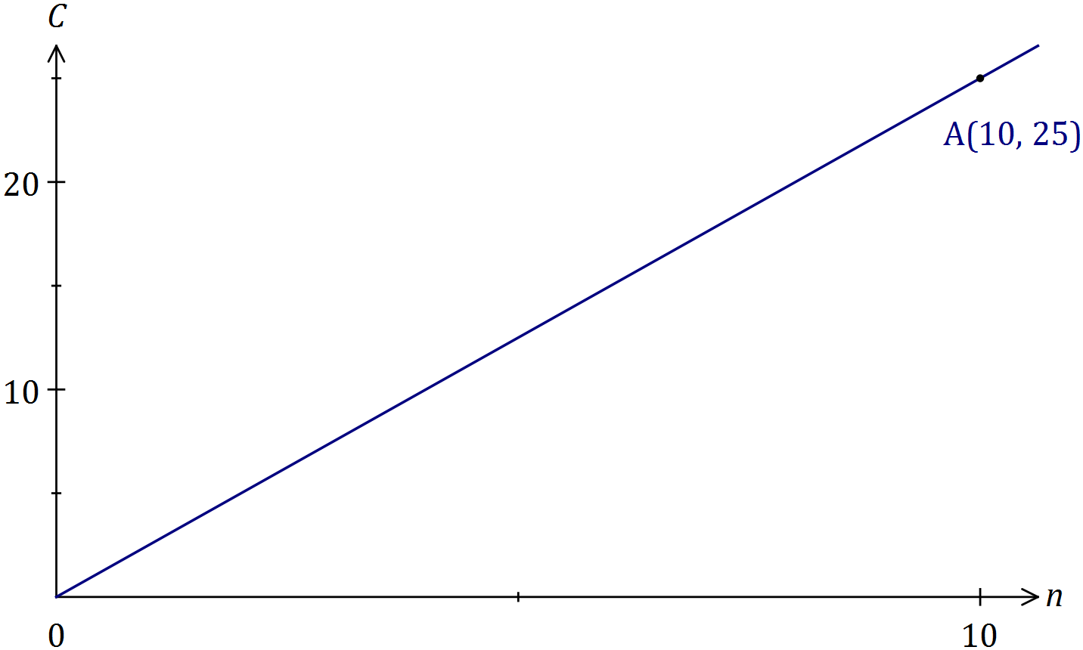

|  |
| --- |
| **Solution** |
| See graph |
| **Specific behaviours** |
| ✓ scales added to both axes  ✓ straight line through origin using ruler  ✓ indicates passes through (10, 25) |

(b) The variables and are inversely proportional to each other, so that when , it is known that .

(i) Write an equation that relates and . (2 marks)

|  |
| --- |
| **Solution** |
|  |
| **Specific behaviours** |
| ✓ correct form of equation  ✓ determines constant |

(ii) Determine the value of when . (1 mark)

|  |
| --- |
| **Solution** |
|  |
| **Specific behaviours** |
| ✓ states value |

**Question 9 (5 marks)**

**(a)** The volume (V) in litres (L) of a gas, at a fixed temperature and of a certain mass, varies inversely to the pressure (P) in Pascals (Pa).

(i) Find *k*, the constant of proportionality, given that when P = 11.5 Pa and V = 2.84 L.

(2 marks)

|  |
| --- |
| **Solution** |
| (i) |
| **Specific behaviours** |
| ✓ states equation  ✓ determines constant |

(ii) Describe the effect on V when P is halved. (1 mark)

|  |
| --- |
| **Solution** |
| The volume doubles. |
| **Specific behaviours** |
| ✓ states double |

**(b)** Jan is a real estate agent who earns a commission of 3.25% on the sale of a house. If $c is the commission and $s is the sale price of a house, show clearly c is directly proportional to s. (2 marks)

|  |
| --- |
| **Solution** |
| is a linear relationship in the form  where  and is therefore directly proportional. |
| **Specific behaviours** |
| ✓ states equation  ✓ shows constant for direct proportion |

**Question 10 (5 marks)**

The reciprocal function 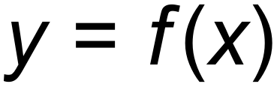 shown below has asymptotes at 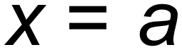 and 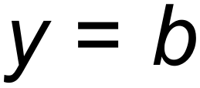.

The *y*-intercept is at (0, *c*).

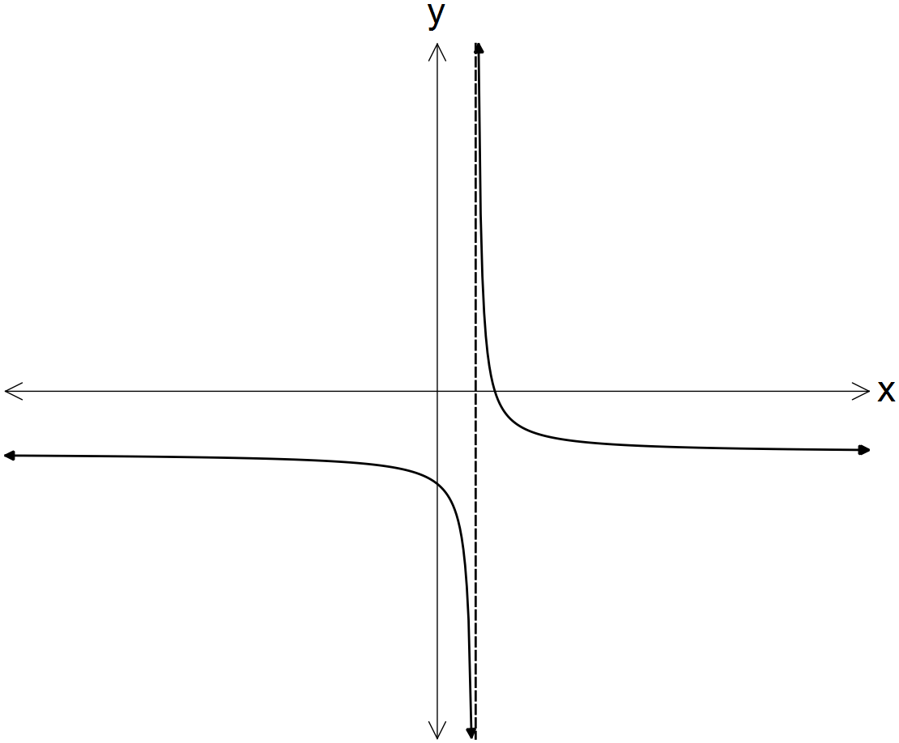

In terms of *a, b* and/or *c*:

**(a)** determine the equation of the horizontal asymptote for 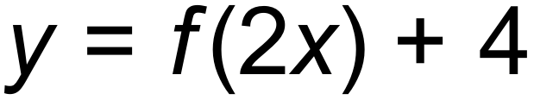. (1 mark)

|  |
| --- |
| **Solution** |
|  |
| **Specific behaviours** |
| ✓ states correct answer |

**(b)** determine the coordinates of the *y*-intercept of 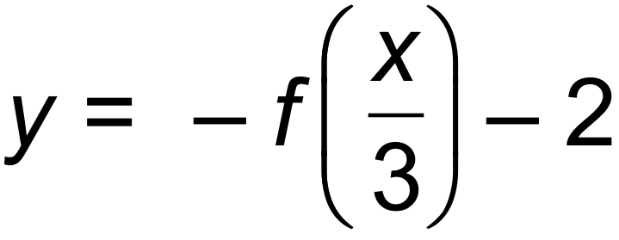. (2 marks)

|  |
| --- |
| **Solution** |
|  |
| **Specific behaviours** |
| ✓ determines y value  ✓ gives as coordinates |

**(c)** state the domain of the function 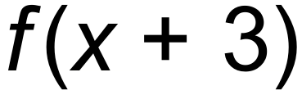. (2 marks)

|  |
| --- |
| **Solution** |
|  |
| **Specific behaviours** |
| ✓ vertical asymptote moves 3 to left  ✓ states domain |

**Question 11 (11 marks)**

Consider the functions graphed below.

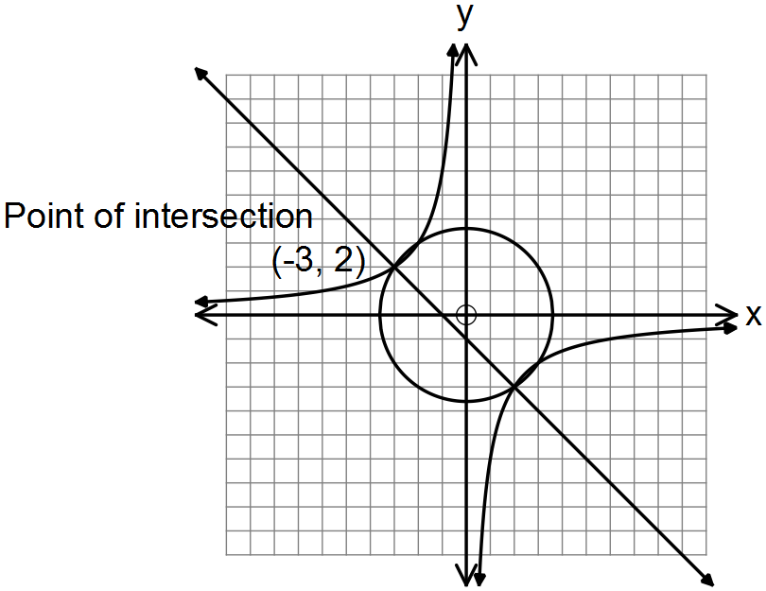

**(a)** State the equation for:

(i) 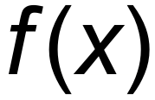, the circle with centre at the origin. (2 marks)

|  |
| --- |
| **Solution** |
|  |
| **Specific behaviours** |
| ✓ uses squared terms  ✓ uses correct radius |

(ii) 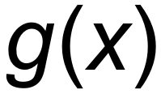, the hyperbola. (2 marks)

|  |
| --- |
| **Solution** |
|  |
| **Specific behaviours** |
| ✓ uses correct format  ✓ use correct constant |

(iii) 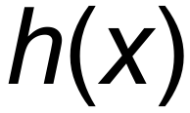, the straight line. (2 marks)

|  |
| --- |
| **Solution** |
|  |
| **Specific behaviours** |
| ✓ correct gradient  ✓ correct constant |

**(b)** Hence, solve the equation 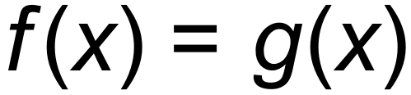. There are four solutions. (2 marks)

|  |
| --- |
| **Solution** |
|  |
| **Specific behaviours** |
| ✓ states two correct solns  ✓ states four correct solns |

**(c)** The graph  undergoes the following transformation 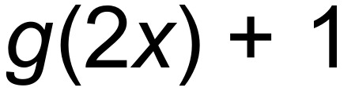.

(i) State the coordinates of the point (–3, 2) after this transformation has occurred.

(2 marks)

|  |
| --- |
| **Solution** |
| () |
| **Specific behaviours** |
| ✓ correct x  ✓ correct y |

(ii) The graph  undergoes the same transformation namely 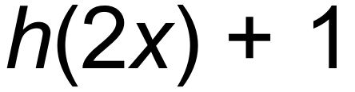. State the gradient of the transformed function. (1 mark)

|  |
| --- |
| **Solution** |
| m = |
| **Specific behaviours** |
| ✓ states correct value |

**Question 12 (7 marks)**

**(a)** Consider the following sets of ordered pairs:

*f* = { (1,2), (2, 3), (3,4) } *h* = { ( 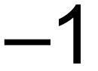, 4), (0, 3), (1,2) }

(i) Find *f* (2). (1 mark)

|  |
| --- |
| **Solution** |
| 3 |
| **Specific behaviours** |
| ✓ states correct value |

(ii) Find *a* such that *h* (*a*) = 3. (1 mark)

|  |
| --- |
| **Solution** |
| 0 |
| **Specific behaviours** |
| ✓ correct value |

(iii)Find *t* such that *f* (*t*) = *h* (*t*). (1 mark)

|  |
| --- |
| **Solution** |
| 1 |
| **Specific behaviours** |
| ✓ correct value |

**(b)** Compare the domain of 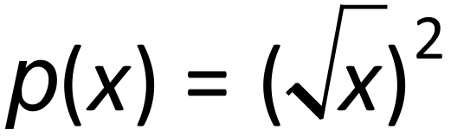 and 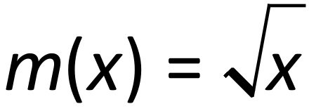. (2 marks)

|  |
| --- |
| **Solution** |
| Domain of  is the same as . For both: |
| **Specific behaviours** |
| ✓ states the same  ✓ shows x greater than or equal to zero |

**(c)** The function, 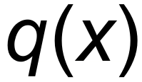 below, is a transformation of 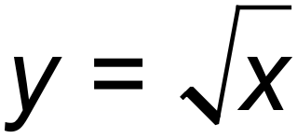.

State the equation of the function, 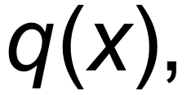 below. (2 marks)

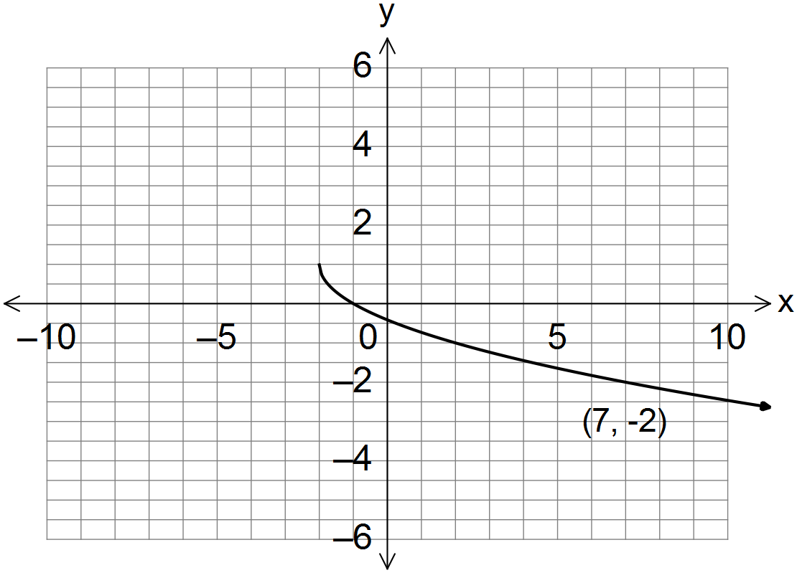

___________________________

|  |
| --- |
| **Solution** |
|  |
| **Specific behaviours** |
| ✓ uses negative sign in front of square root  ✓ correct function |

**Question 13 (6 marks)**

The following functions are shown below:

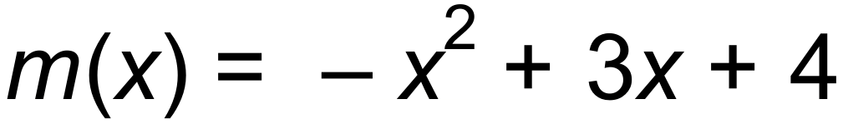 and 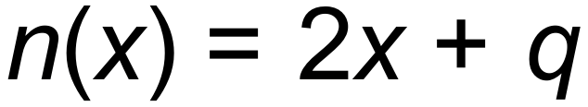, where *q* is a constant.

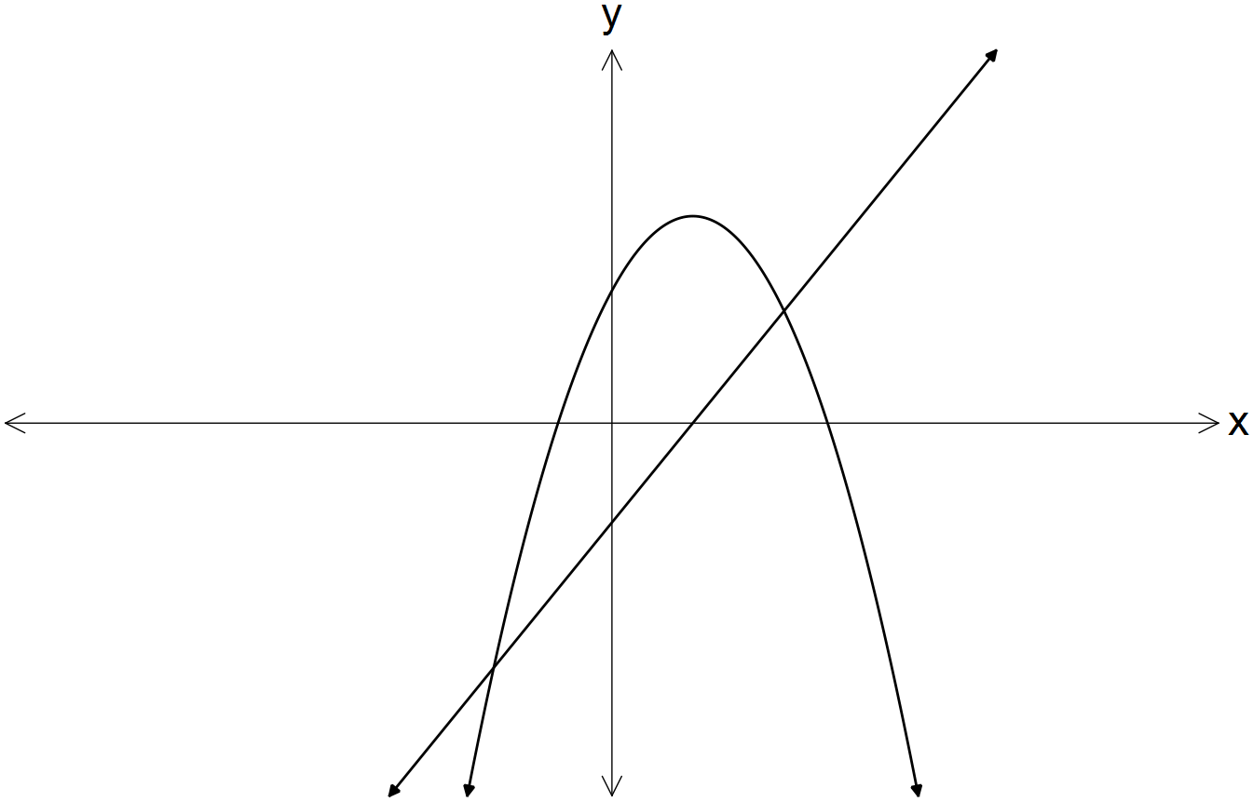

For what value(s) of *q* does the equation 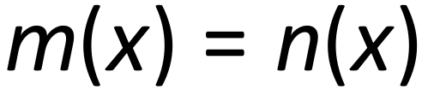 produce:

**(a)** one solution? (4 marks)

|  |
| --- |
| **Solution** |
| for one solution |
| **Specific behaviours** |
| ✓ equates y values  ✓ determines discriminant of quadratic equation  ✓ equates to zero  ✓solves for q |

**(b)** no real solutions? (2 marks)

|  |
| --- |
| **Solution** |
|  |
| **Specific behaviours** |
| ✓ states discriminant is less than zero  ✓ solves inequality |

Question 14 (8 marks)

(a) The graph of has a line of symmetry with equation .

(i) Determine the value of . (2 marks)

|  |
| --- |
| **Solution** |
|  |
| **Specific behaviours** |
| ✓ uses line of symmetry  ✓ value of |

(ii) Draw the graph of the parabola on the axes below. (3 marks)

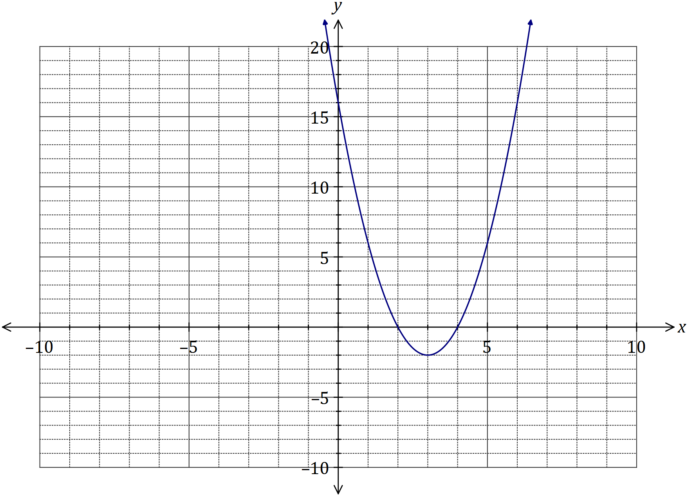

|  |
| --- |
| **Solution** |
| See graph |
| **Specific behaviours** |
| ✓ turning point  ✓ three axes intercepts  ✓ smooth curve |

(b) One of the solutions to the equation is . Determine the value of and all other solutions. (3 marks)

|  |
| --- |
| **Solution** |
| Using CAS, when  Use CAS to solve |
| **Specific behaviours** |
| ✓ substitutes  ✓ determines  ✓ states other two solutions |

**Question 15 (5 marks)**

**(a)** State the centre, *C*, and the radius, *r*, of the circle given by .

(2 marks)

|  |
| --- |
| **Solution** |
| Centre (3,5) radius 6 |
| **Specific behaviours** |
| ✓ states centre  ✓ states radius |

**(b)** Write a possible equation, in terms of a, b and/or c, which are positive constants, for each graph shown below.

(3 marks)

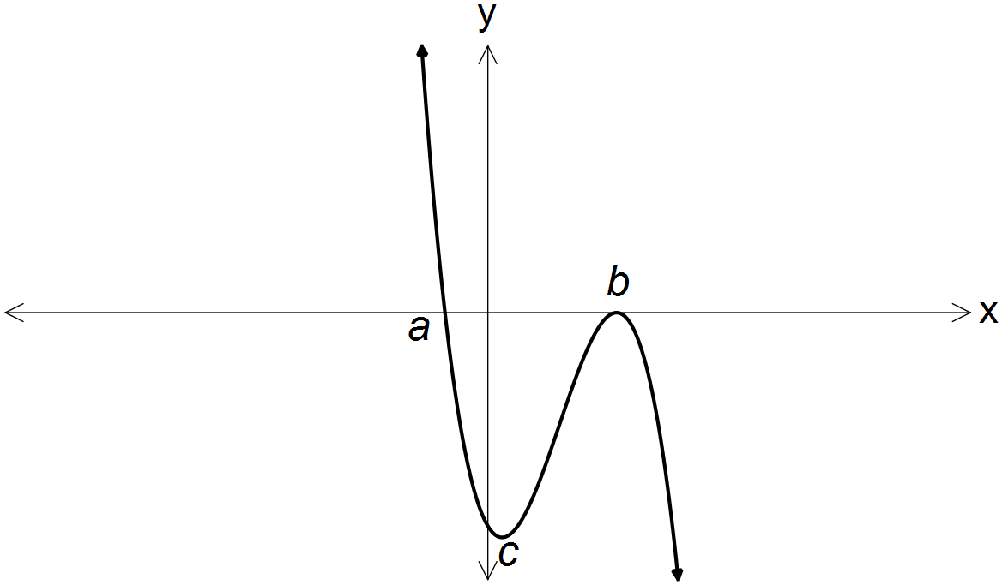 (i)

_________________________

|  |
| --- |
| **Solution** |
|  |
| **Specific behaviours** |
| ✓ correct expression |

(ii)

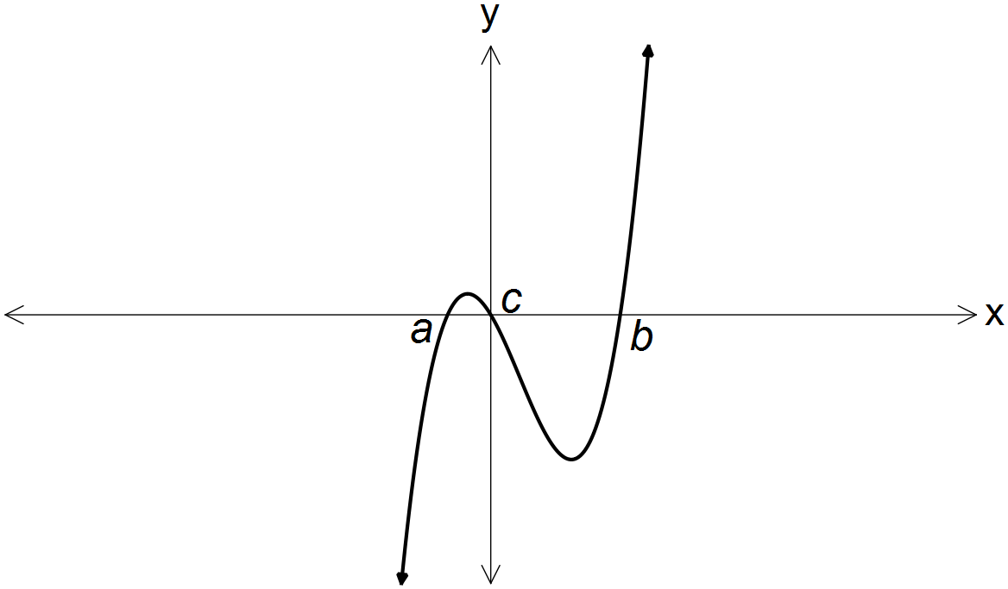

_________________________

|  |
| --- |
| **Solution** |
|  |
| **Specific behaviours** |
| ✓ correct expression |

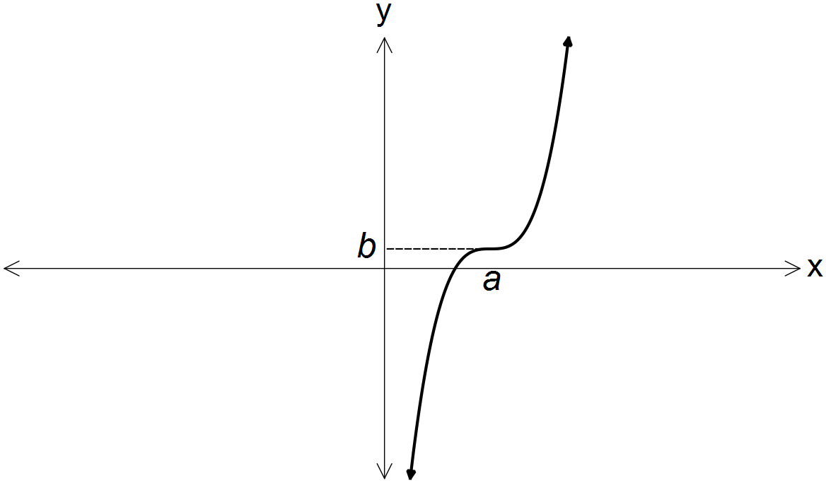

(iii)

_________________________

|  |
| --- |
| **Solution** |
|  |
| **Specific behaviours** |
| ✓ correct expression |

Question 16 (8 marks)

The graph of the function is defined by is shown below.

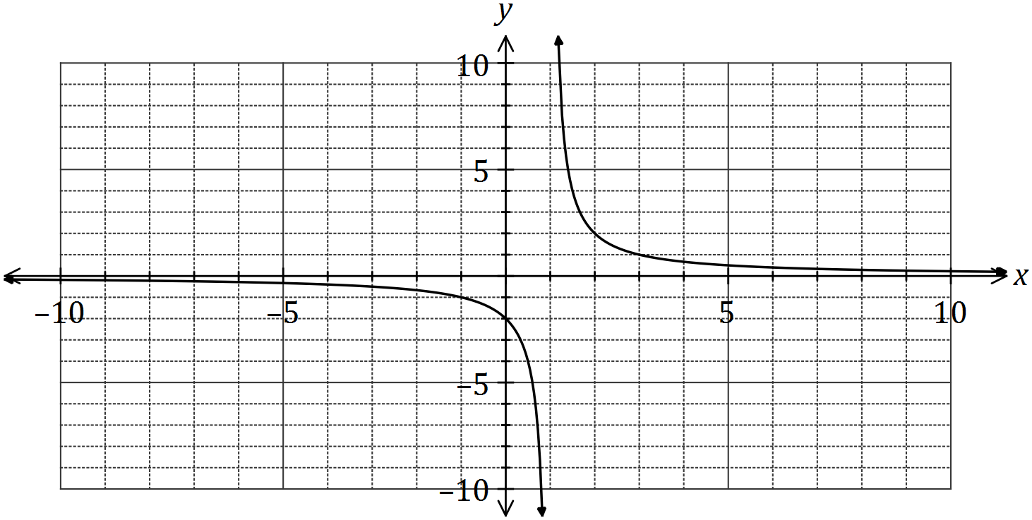

(a) Determine the values of and . (2 marks)

|  |
| --- |
| **Solution** |
| Using vertical asymptote,  Using -intercept, |
| **Specific behaviours** |
| ✓ value of , ✓ value of |

(b) State the domain and range of . (2 marks)

|  |
| --- |
| **Solution** |
|  |
| **Specific behaviours** |
| ✓ indicates , ✓ indicates |

(c) Determine the equations of the asymptotes of the graph of . (2 marks)

|  |
| --- |
| **Solution** |
| Vertical asymptote: , horizontal asymptote: |
| **Specific behaviours** |
| ✓ vertical asymptote, ✓ horizontal asymptote. |

(d) Describe the transformation required on the graph of to obtain the graph of

(i) . (1 mark)

|  |
| --- |
| **Solution** |
| Translate 8 units to the left. |
| **Specific behaviours** |
| ✓ description |

(ii) . (1 mark)

|  |
| --- |
| **Solution** |
| Dilate vertically by scale factor |
| **Specific behaviours** |
| ✓ description |

Question 17 (8 marks)

Let 

1. Sketch the function on the axes below. (6 marks)

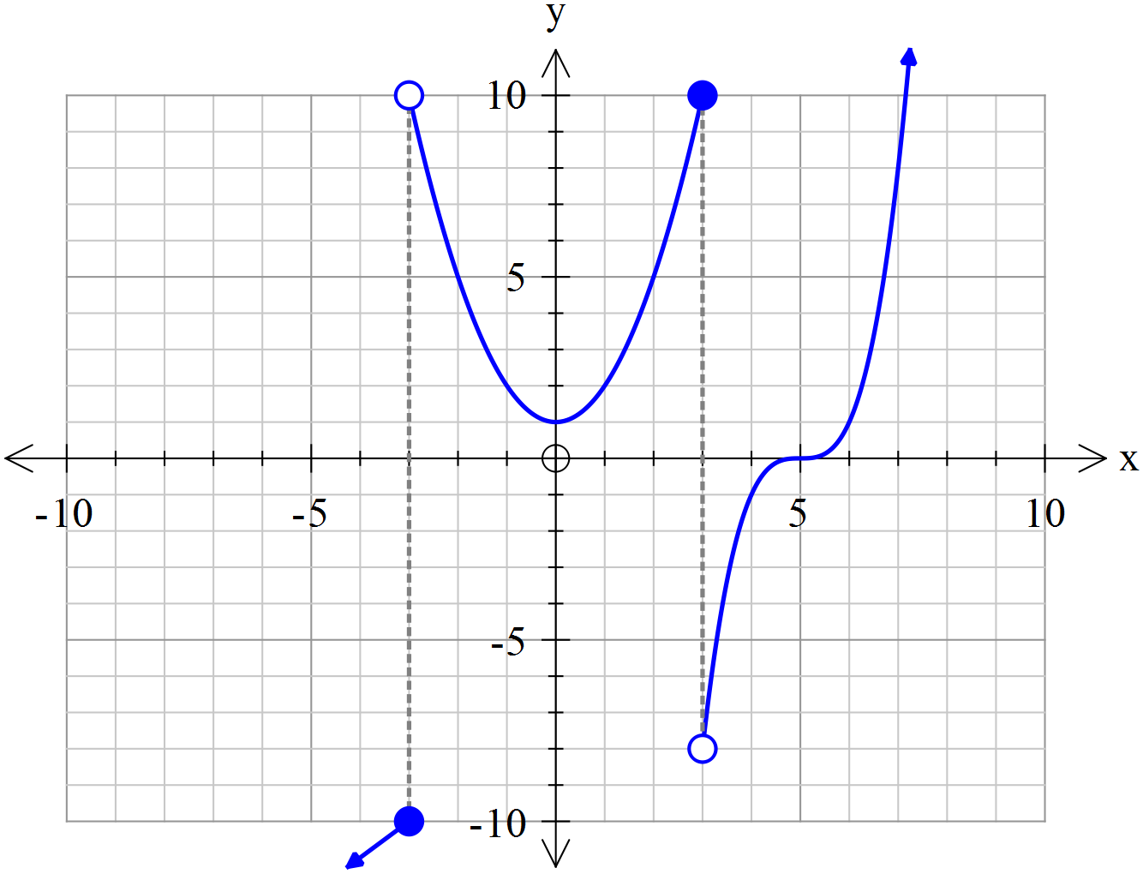

|  |
| --- |
| **Solution** |
|  |
| **Specific behaviours** |
| ✓ correct circle shaded for x=-3  ✓ correct circle shaded fpr x=3  ✓y intercept shown  ✓ x intercept shown  ✓correct shape of function at x-3  ✓ all sections have correct shape |

1. State the maximal(natural) domain and range. (2marks)

|  |
| --- |
| **Solution** |
| Domain R  Range  or |
| **Specific behaviours** |
| ✓ correct domain  ✓ correct range |

Question 18 (8 marks)

1. A quantity z varies partly as directly proportional to x squared plus directly proportional to y cubed. For x=7 and y=11, z = 4189. For x=12 and y=5, z=951. Determine the value of z for x=9 and y=15. (4 marks)

|  |
| --- |
| **Solution** |
|  |
| **Specific behaviours** |
| ✓ writes equation for z in terms of two constants  ✓ sets up two equations with constants  ✓ solves both constants  ✓determines final value of z |

1. If  determine the percentage change in w if x decreases by 30% and y increases by 20%. (4 marks)

|  |
| --- |
| **Solution** |
|  |
| **Specific behaviours** |
| ✓ uses 0.7 for x  ✓ uses 1.20 for y  ✓ subs into equation for w  ✓states a decrease of 69% |

Question 19 (6 marks)

1. Determine the quotient and remainder when  is divided by  (4 marks)

|  |
| --- |
| **Solution** |
|  |
| **Specific behaviours** |
| ✓ uses long division method  ✓ determines squared term of quotient  ✓ determines complete quotient and states this as the quotient  ✓determines and labels remainder |

1. Determine the value of the constant  so that is a factor of  (2 marks)

|  |
| --- |
| **Solution** |
|  |
| **Specific behaviours** |
| ✓ sets up equation with constant  ✓ solves for constant |

© 2016 WA Exam Papers. Rossmoyne Senior High School has a non-exclusive licence to copy and communicate this paper for non-commercial, educational use within the school. No other copying, communication or use is permitted without the express written permission of WA Exam Papers. SN085-092-4.